**CCNA - PROJECT -3**

**RIP with manual routing**

* **REQUIREMNTS:**

**3-ROUTER**

**2-SWITCHES**

**4-PC**

**1-SERVER**

* ASSIGN IP’S TO THE ROUTER’S

ROUTER-0 [192.168.10.1]

ROUTER 0—1 [10.0.0.0]

ROUTER -1 [192.168.30.0]

ROUTER 1---2 [10.0.1.0]

ROUTER-2 [192.168.20.1]

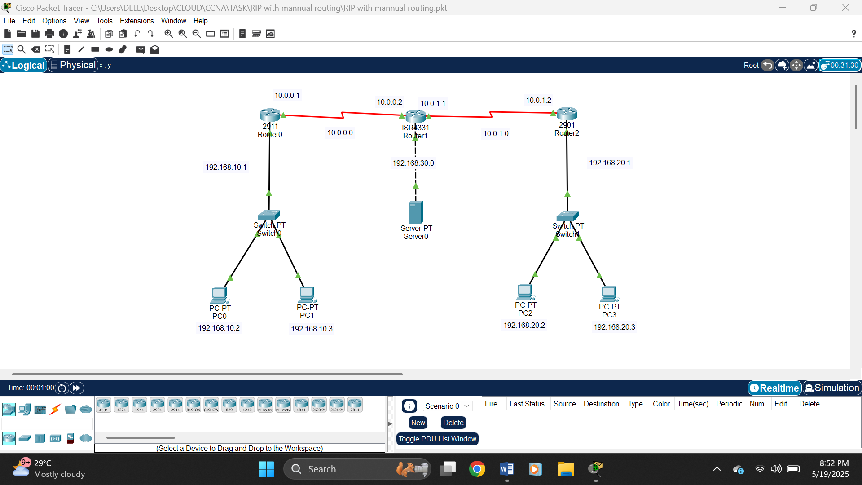

* ASSIGN IP TO THE PC’S

PC -> DESKTOP -> IP CONFIG -> STATIC

PC 0-1 [192.168.10.2-3]

PC 2-3 [192.168.20.2-3]

* **SCRIPT IS GIVEN IN THE TXT (NOTEPAD) FORMAT.**

AFTER CONFIGURATION

PING PC TO PC

HERE I HAVE ATTACHED START PC1 to PC2 & PC3

TO PING THE DEVICE GOTO PC DESKTOP -> COMMAND PROMT

DATA SHARING IMG INSERTEDD IN BELOW:

